Karakaj bb, 75400 Zvornik  Republic of Srpska, Bosnia and Herzegovina  Phone: +387 (0) 56 / 260 970, 260 435  Fax: +387 (0) 56 / 260 726  http://www.aluminazv.ba | 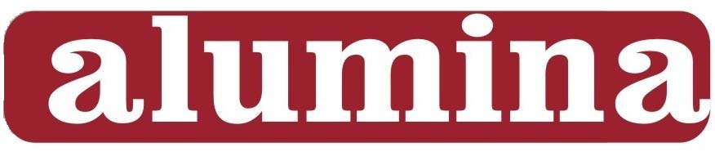  „Alumina” d.o.o.  Zvornik

PRODUCT DATA SHEET

CALCINED ALUMINA – WHITE

Main application: For non-metallurgical programs.

Chemical Characteristics
Typical content Guaranteed limits
Al₂O₃ | [%] | 98.8 – 99,0 | 98,7 min
SiO₂ | [%] | 0,005 – 0,010 | 0,015 max
Fe₂O₃ | [%] | 0,008 – 0,012 | 0,018 max
Na₂O_{total} | [%] | 0,25 – 0,40 | 0,45 max
CaO | [%] | 0,018 – 0,025 | 0,030 max
P₂O₅ | [%] | 0,0002 – 0,0005 | 0,0009 max
TiO₂ | [%] | 0,0020 – 0,0027 | 0,003 max
ZnO | [%] | 0,017 – 0,025 | 0,028 max

Physical Characteristics
Typical range Guaranteed limits
Specific surface area BET | [m²/g] | 70 - 90 | 65 min
Bulk Density | [kg/m³] | 950 - 1000 | 1050 max
Loss on ignition L.O.I. (300°C -1000°C) | [%] | 0,6 – 1,0 | 1,2 max
Moisture (100 °C) | [%] | 0,6 – 2,0 | 2,5 max
Angle of repose | [°] | 32 - 34 | 35 max
d₅₀ | [µm] | 40– 55 | 60 max

+ 45 μm (wet sieve) | [%] | 40 - 50 | 55 max

The above values have been determined by the measuring methods and instruments of Alumina doo Zvornik.

Product is available in bulk, containers or packaged depending on our customer requirements and available for delivery in the following modes of transport:
- Road - silo trucks, silo containers, pallets
- Rail - bulk and pallets

Compliance: This product is REACH compliant, ask Alumina doo for the associated REACH
registration details.

