Karakaj bb, 75400 Zvornik  Republic of Srpska, Bosnia and Herzegovina  Phone: +387 (0) 56 / 260 970, 260 435  Fax: +387 (0) 56 / 260 726  http://www.aluminazv.ba | 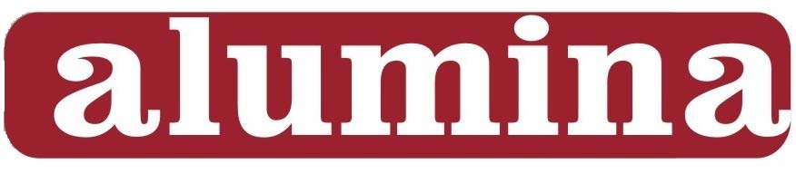  „Alumina” d.o.o.  Zvornik

Origination Date: 30.03.2016.
Version: 1
PRODUCT DATA SHEET

HydrAl 100 - P
Aluminium hydroxide – dried

Main application: For aluminium salts production, ceramic industry, refractory materials, cement industry, glass industry, filler in different areas etc.

Chemical Characteristics
Typical content Guaranteed limits
Al₂O₃ | [%] | 64,7 – 65,5 | 64,5 min
SiO₂ | [%] | 0,003 – 0,007 | 0,009 max
Fe₂O₃ | [%] | 0,006 – 0,010 | 0,02 max
Na₂O_{total} | [%] | 0,08 – 0,10 | 0,12 max
CaO | [%] | 0,012 – 0,016 | 0,10 max
C | [%] | 0,02 - 0,05 | 0,1 max

Physical Characteristics
Typical range Guaranteed limits
Moisture (100 °C) | [%] | 0,03 – 0,1 | 0,2 max
Loss on ignition L.O.I. (1000°C) | [%] | 34,5 – 35 | 35,5 max
Middle diameter d₅₀ (wet sieve) | [µm] | 95 - 120 | 95 min
< 20 µm (wet sieve) | [%] | 1 – 3 | 3 max
< 40 µm (wet sieve) | [%] | 2 - 6 | 6 max
< 60 µm (wet sieve) | [%] | 5 - 15 | 15 max
< 80 µm (wet sieve) | [%] | 15 - 35 | 25 max
< 105 µm (wet sieve) | [%] | 35 - 60 | 60 max
< 149 µm (wet sieve) | [%] | 60 - 90 | 75 min
< 312 µm (wet sieve) | [%] | 100 | 100 min

The

TThe above values have been determined by the measuring methods and instruments of Alumina doo Zvornik.

Product is available in bulk, containers or packaged depending on our customer requirements and available for delivery in the following modes of transport:
- Road - bulk and pallets
- Rail - bulk and pallets

Compliance: This product is REACH compliant, ask Alumina doo for the associated REACH
registration details.

